**Spades Term Project Proposal**

**Project Description**

Name: Spades

Description: This is a classic 4 player card game. There are two teams of two players. Each player is dealt 13 cards. Each round there are 13 tricks played. To start the round each player bids on how many tricks they are going to win. In each trick the highest card of the starting suit wins unless a spade is played. Highest spade always wins no matter what. The points gained are based on how accurately the team made their bids. If a team had a player bid 4 and a player bid 3 then their bid is 7. If they make their 7 they get 70 points but if they dont they get -70 points. First team to 500 wins.

**Competitive Analysis**

I found two great versions of this game online. The first is an app called Spades+. This game is a great version of spades that I’ve played for a long time. The player can customize the cards, difficulty, partners strategy, and winning score. There are great animations for dealing the cards and playing the cards. I am basing my background off the layout of this game as it looks stunning. Very similar looks to a poker table or similar casino style game. However my version of this game will implement some of the more abstract rules that me and my brothers would play with and this version doesn’t. My version of this game will implement the two of clubs rule that essentially says at the start of the round whoever has the two of clubs starts while this version makes it so that the player who starts the round rotates and can choose any card. Furthermore I will implement blind nill which is a risky comeback strategy that can be used if the player is feeling lucky or if they need a big comeback.

The second version of this game I found was an online simulator linked below. This version is significantly harder to interpret what's happening. The colors are very loud and the method for choosing and displaying the bids is small and doesn’t draw any attention. This shows me what not to do. The one upside to this version is that it has beautiful animations for dealing and playing cards as well. I am hoping to implement similar animations once I reach MVP.

Link: <https://cardgames.io/spades/>

**Structural Plan**

The final project will be one main file organized into subsections of functions.

The sections are as follows: start ups for games and rounds, helper functions for small needs in the program, functions to help the player in determining their best cards, playing their cards,bidding,etc, functions for the 3 cpus strategy and bidding strategy, and finally functions to display things on the screen.

The main functions of the project is the algorithm for the CPUs choosing cards, the

Images for suits and game icons will be stored as png files and they were all drawn in procreate with references.

**Algorithmic Plan**

The most complex algorithm in this project is used to decide the cards the 3 AI play. To do this it will use an alpha-beta pruning algorithm. To decide the best move to play this AI will look at all the unplayed cards and all the legal cards that are in the AI’s hand. It will run all the possible situations that the remaining players in the trick can choose and whichever card has the most positive outcomes for the AI or the AI’s partner is the card that the AI will choose.

Alpha pruning just looks ahead into the future at the possible outcomes and by knowing this it can evaluate the best card.

**Timeline Plan**

-Major Functions and graphics in the program are done by Thursday 18th

* Creating Hands
* Player can play cards
* AI can play cards
* Player can’t play illegal cards
* Keeps track of score
* Simple bidding algorithm for AIs

-Smaller features and AI done by Sunday 21st. This includes smaller rules and players input and everything

* Alpha pruning
* Spades being broken
* Nill
* Restarting rounds
* Fixing bugs

-Graphics and animation improved by November 30th

* Animations for dealing cards
* Animations for playing cards
* Improve jumpiness of AI with time delays
* Card sound effects if time permits?
* Player Images
* Home screen
* Help screen
* Settings for end score 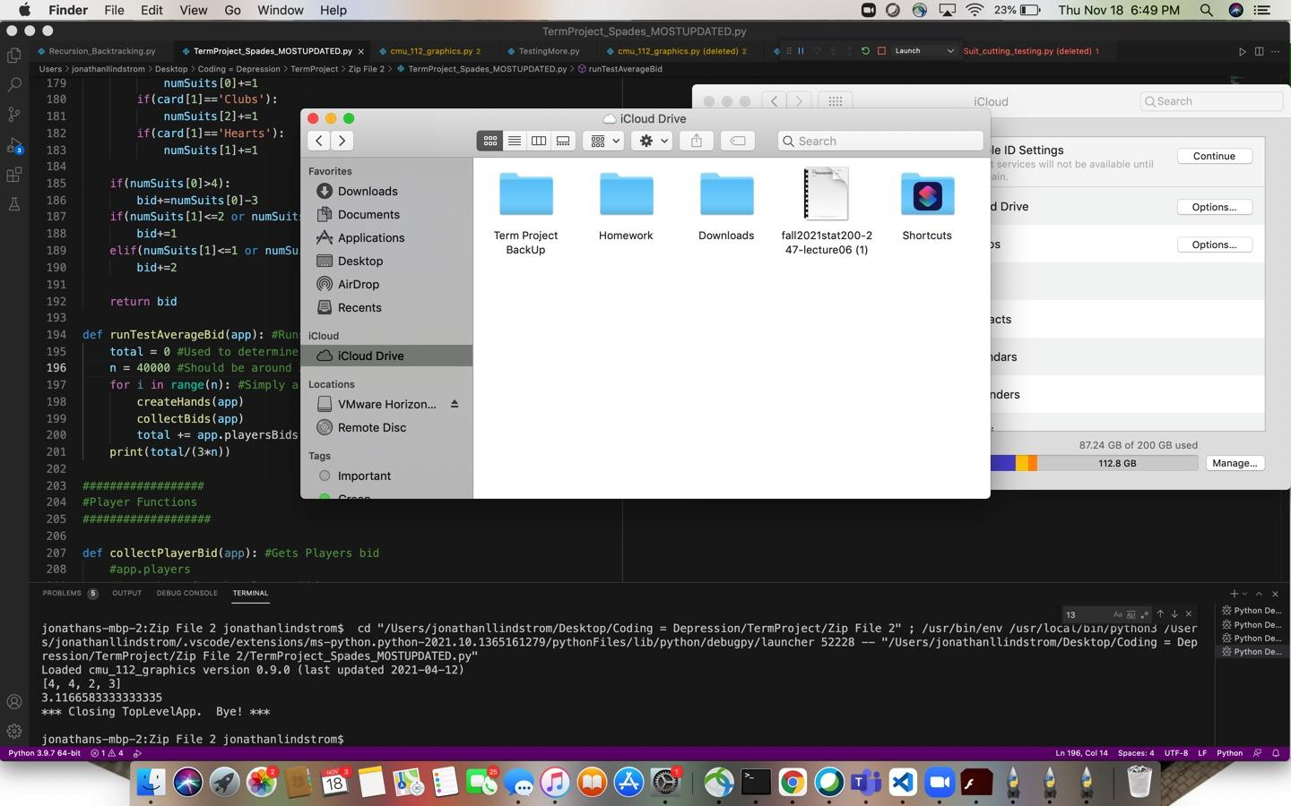

**Version Control Plan**

Stored in my ICloud

File: Term Project Back up under my icloud has everything

**Module List**

No Additional Modules

**TP3 Update:**

-Added a resume feature

-Other than that no additional updates

-Additional sound effects and animations didn’t get included